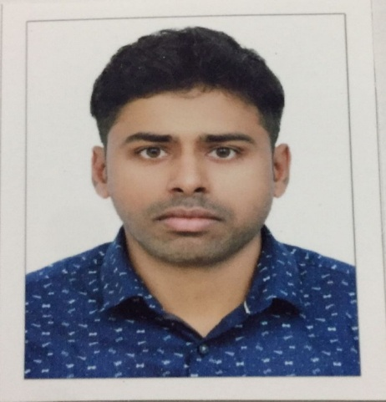
RESUME
MUHAMMED FAISAL
URUNNIYAN ( H)
THELAKKAD ( PO)
PATTIKKAD ( VI )
MALAPPURAM 9 DT )
KERALA- INDIA
PIN- 679325
Mob:+971-0507403428
Email : faisaltkd123@gmail.com

Career Objective

Looking for a challenging career in an organisation where my functional knowledge & sincerity can be best utilised to provide a premium value services to the organisation and which will lead to a better career prospect.

Qualification

Professional Qualification

- S.SL.C (Kerala Examination Board)
- PLUS TWO (Higher Secondery)
- BCOM (Calicut University)

Computer Skills

- MS-Office (Word, Excel, PowerPoint & Access)
- Tally (Diploma in financial accounting)

Languages Known

- English (Speaking, Writing, Reading & Typing)
- Hindi and Malayalam (Speaking, Reading and Writing)
- Arabic (Reading and writing)

Work Experience

- Worked as Accountant in Sylcon shoes &bages in Eranakulam 4 year
Experience

Personal Details

Age & Date of Birth : 29 Years, 02-02-1991
Father Name : SULAIMAN
Permanent Address :
Urunniyan house,
Thelakkad (po)
Pattikkad(v)
Malappuram(d)
Kerala-India
Pin - 679325

Sex : male

Languages known : English, Hindi, Malayalam & Arabic

Marital Status : Married

Nationality : Indian

Hobbies : PLAYING

Declaration

I hereby declare that the above details are true and best of my knowledge.

Date : 23-03-2022 Yours Sincerely,
Place : PERINTHALMANNA MUHAMMED FAISAL. U

